Exercise07_12

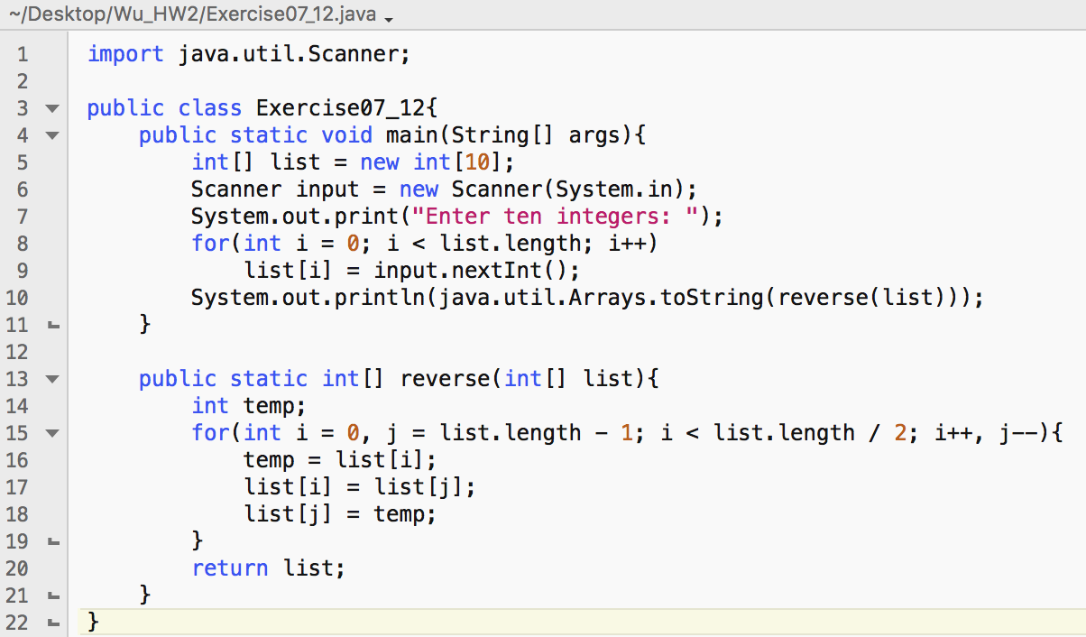

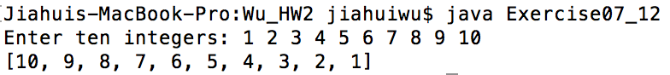

Exercise07_17

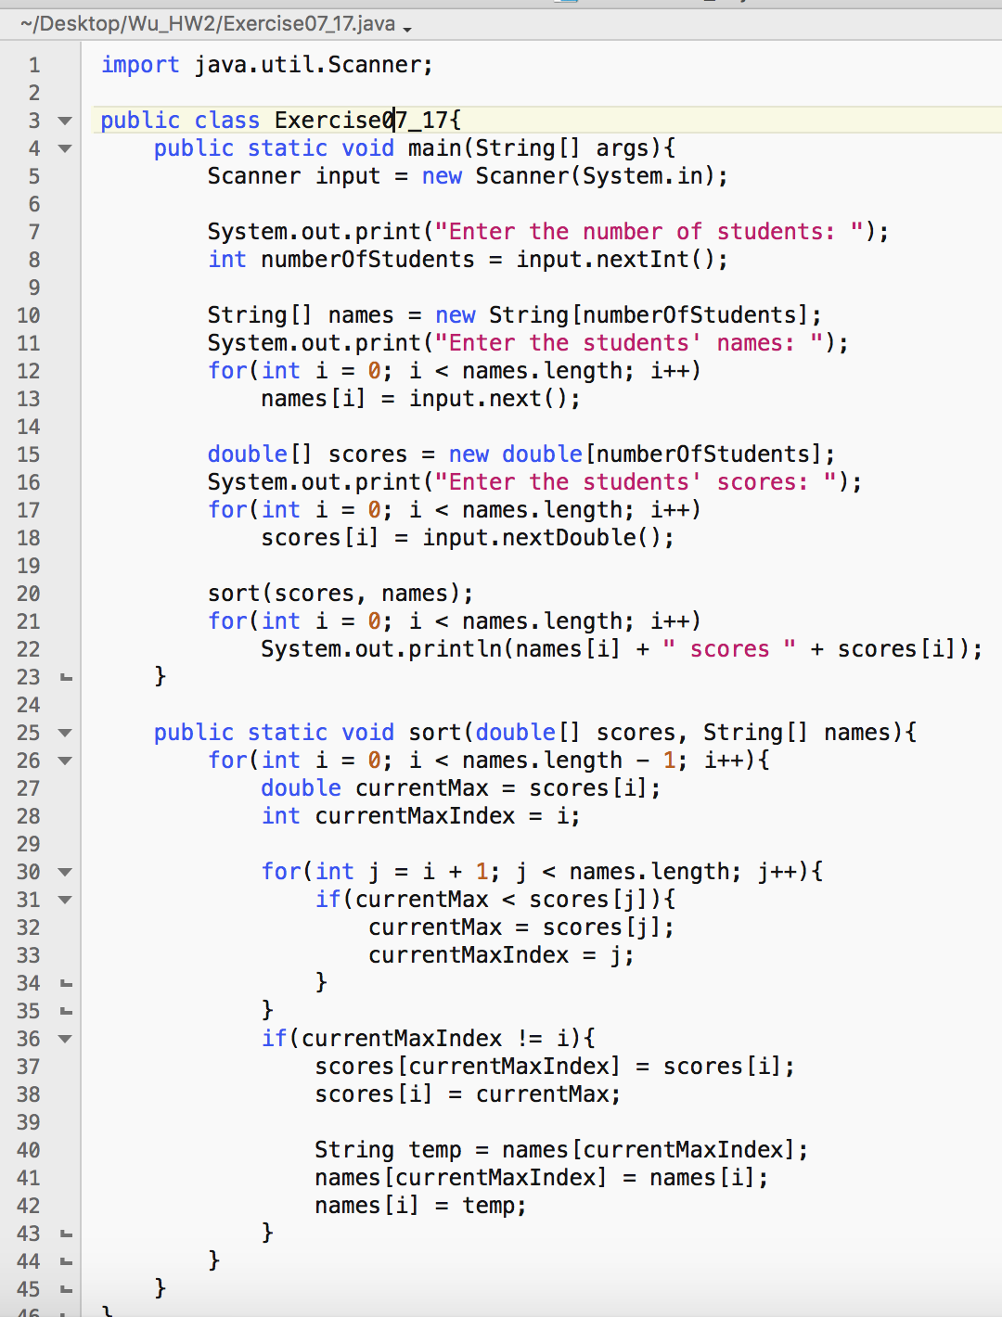

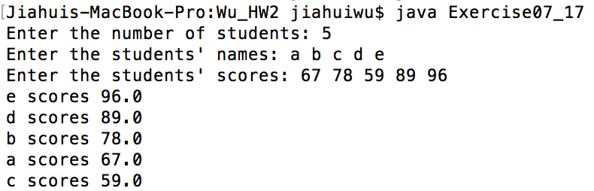

Exercise07_18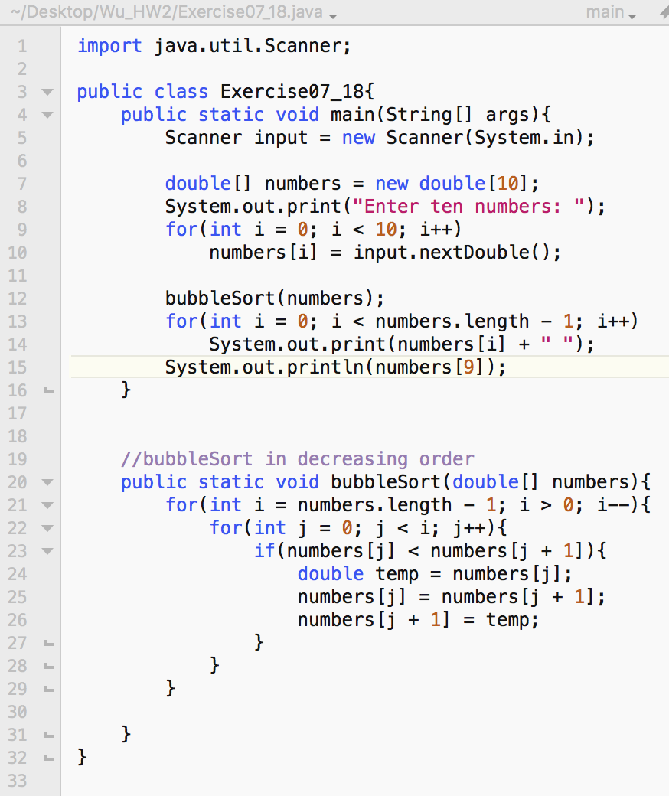

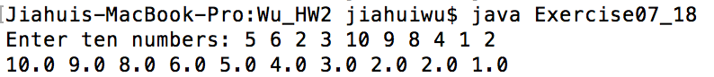

Exercise08_4

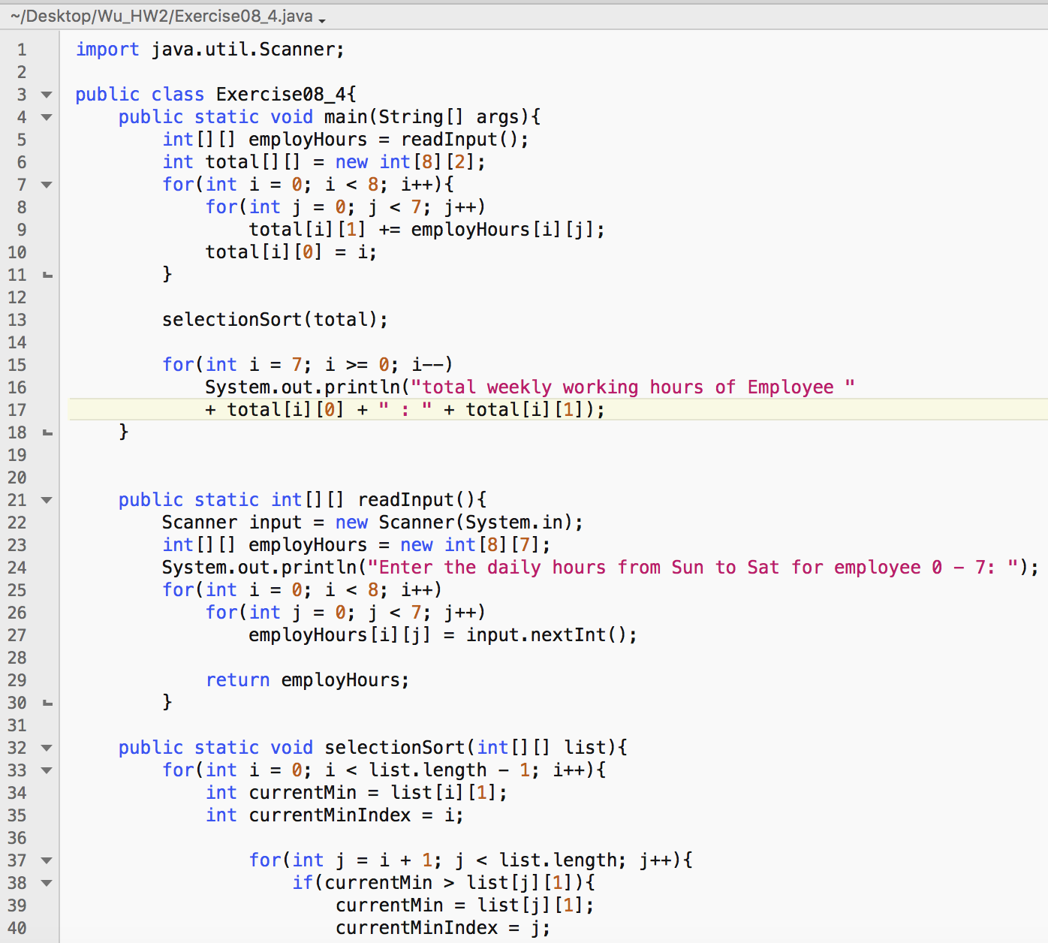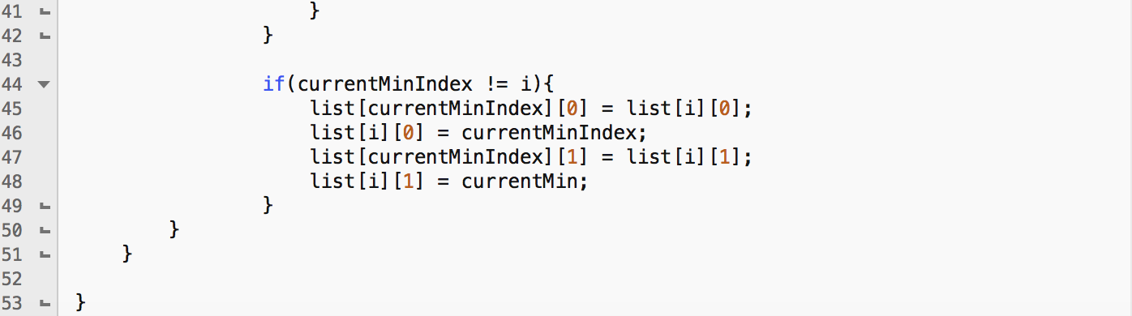

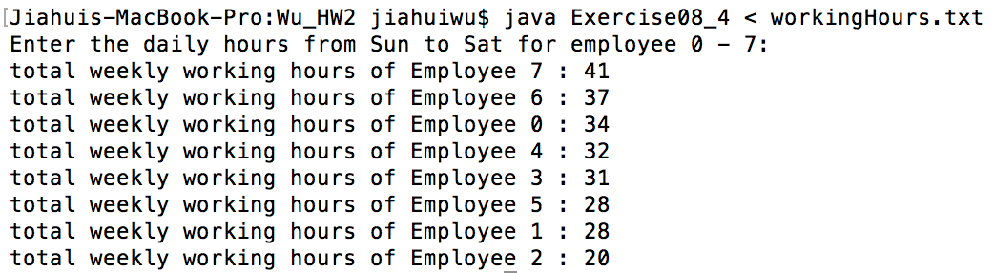

Exercise08_6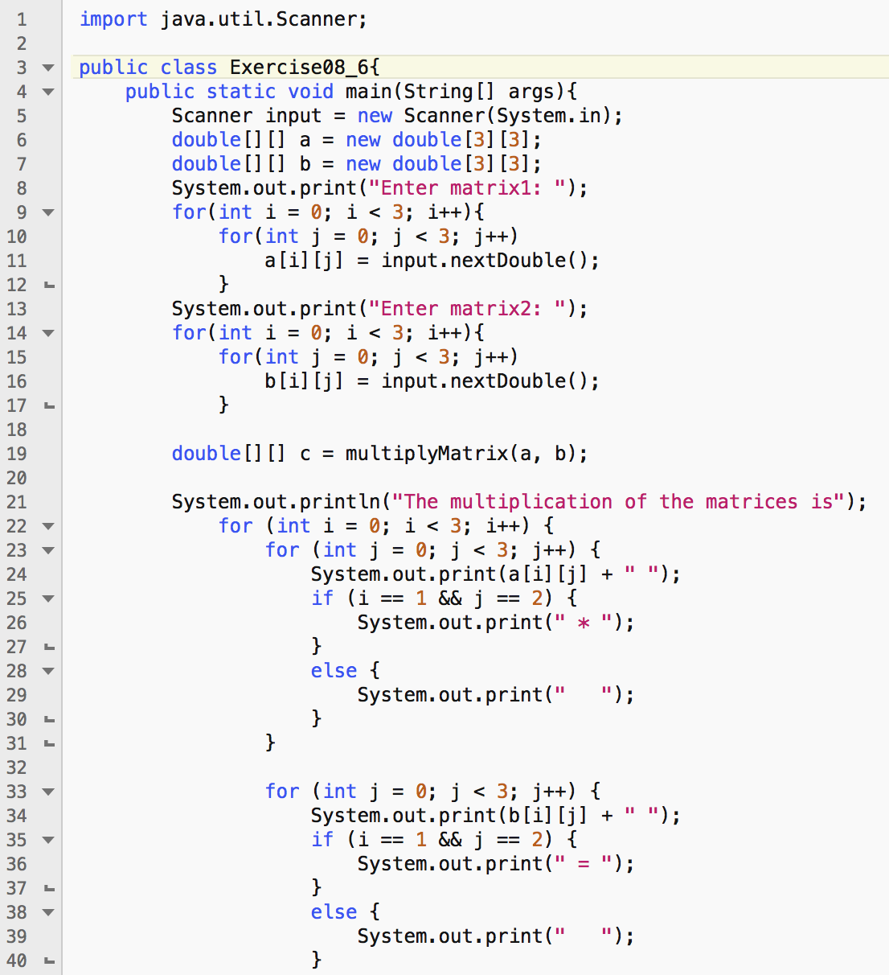

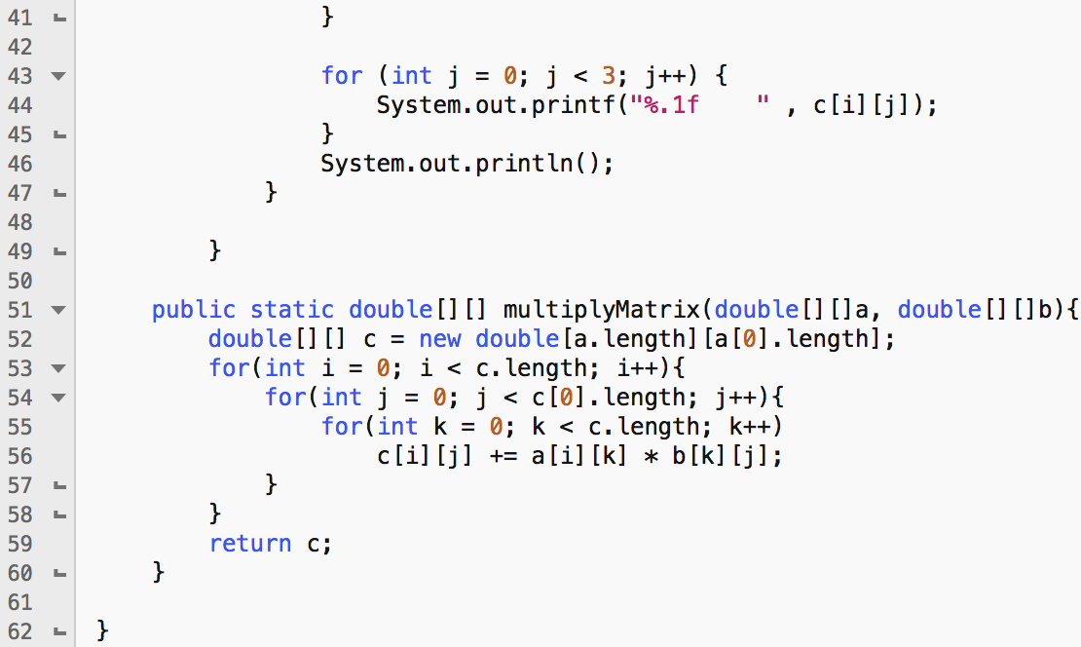

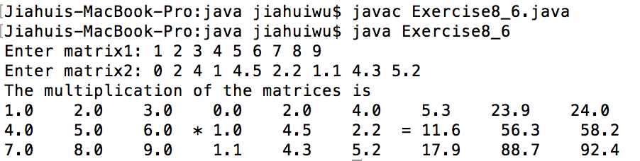

Exercise08_10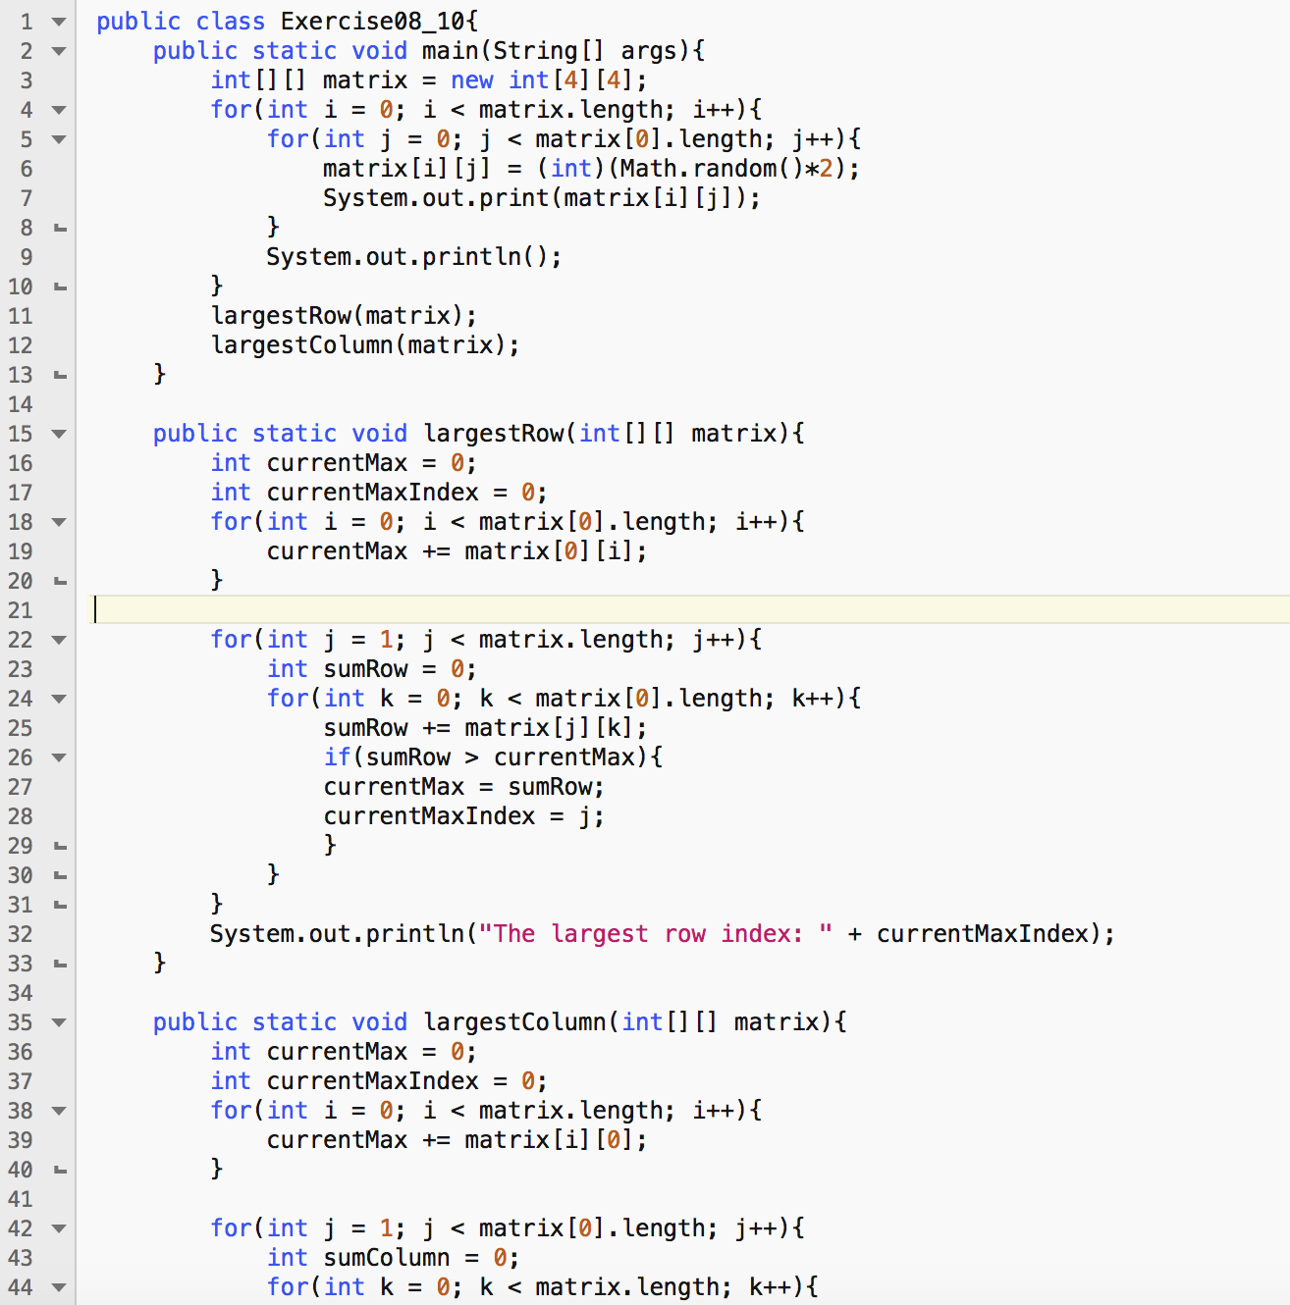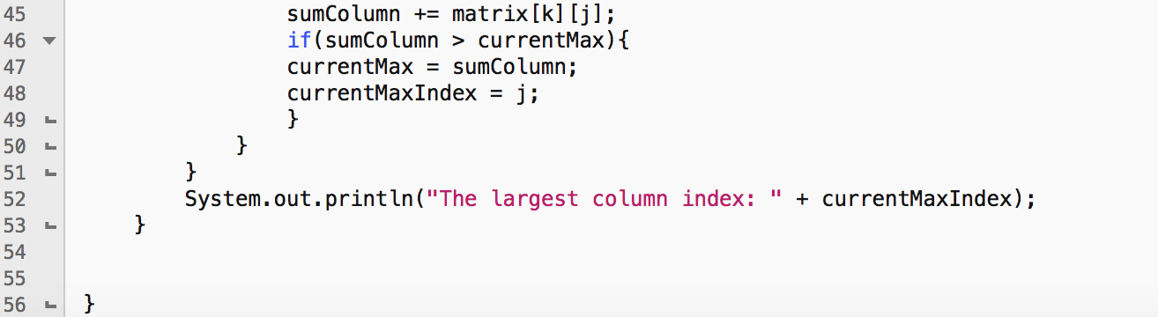

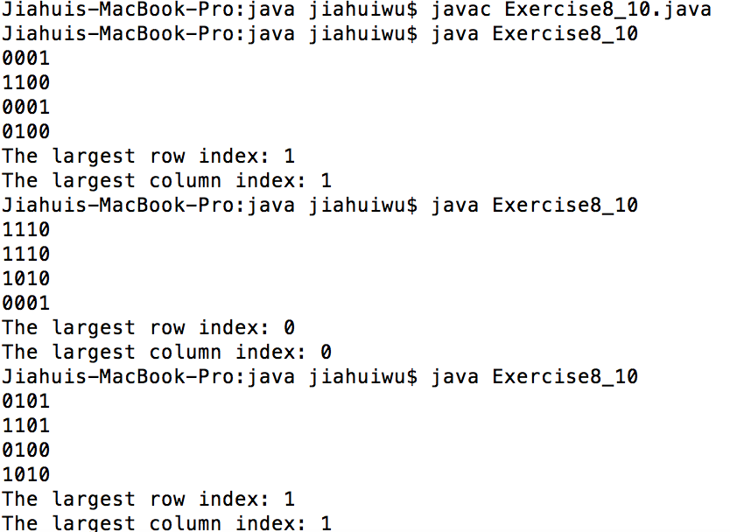

Exercise09_10

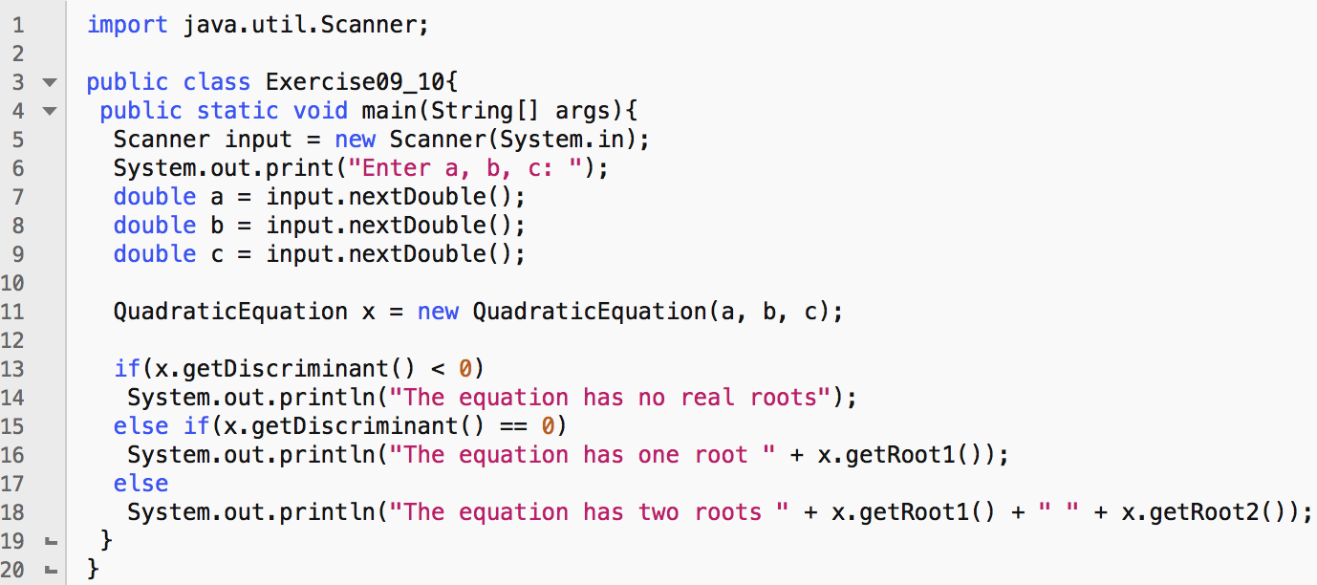

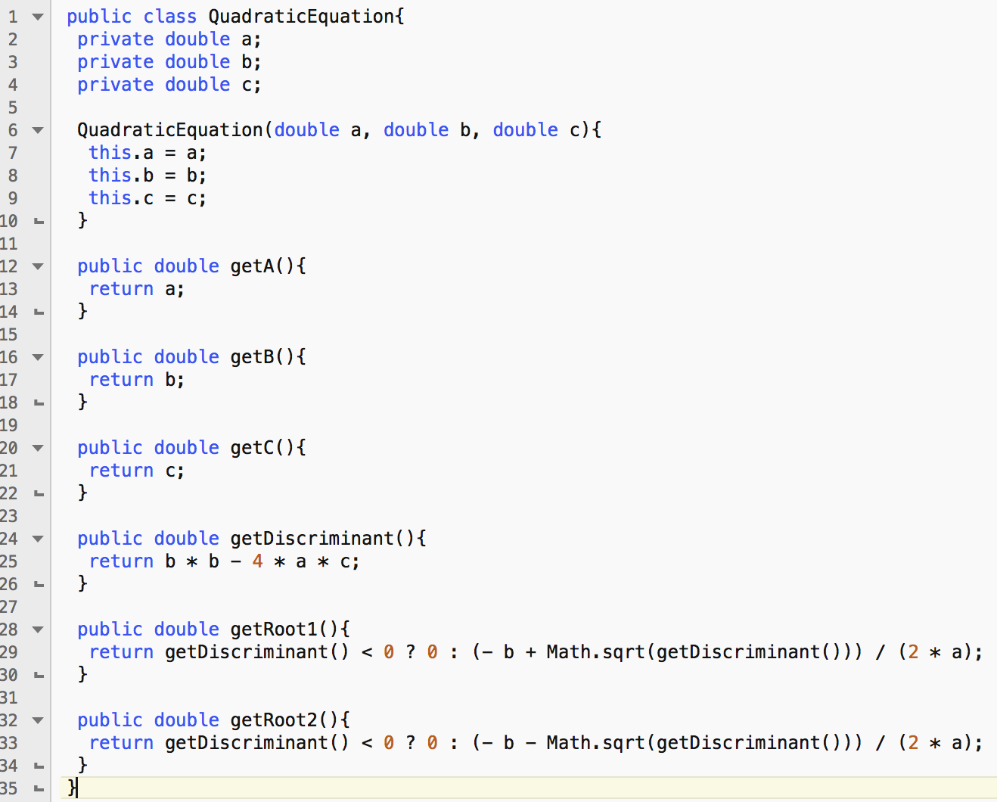

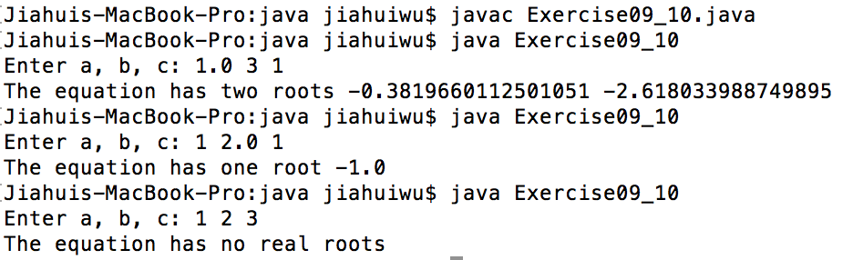

========================================

**QuadraticEquation**

-------------------------------------------------------------------

-a: double

-b: double

-c: double

-------------------------------------------------------------------

+QuadraticEquation(a: double, b: double, c: double)

+getA(): double

+getB(): double

+getC(): double

+getDiscriminant(): double

+getRoot1(): double

+getRoot2(): double

========================================

Exercise09_11

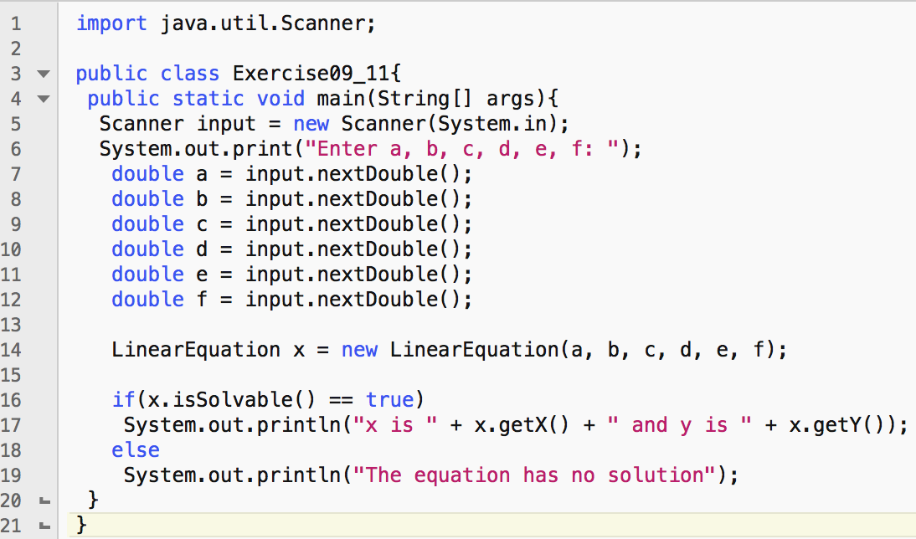

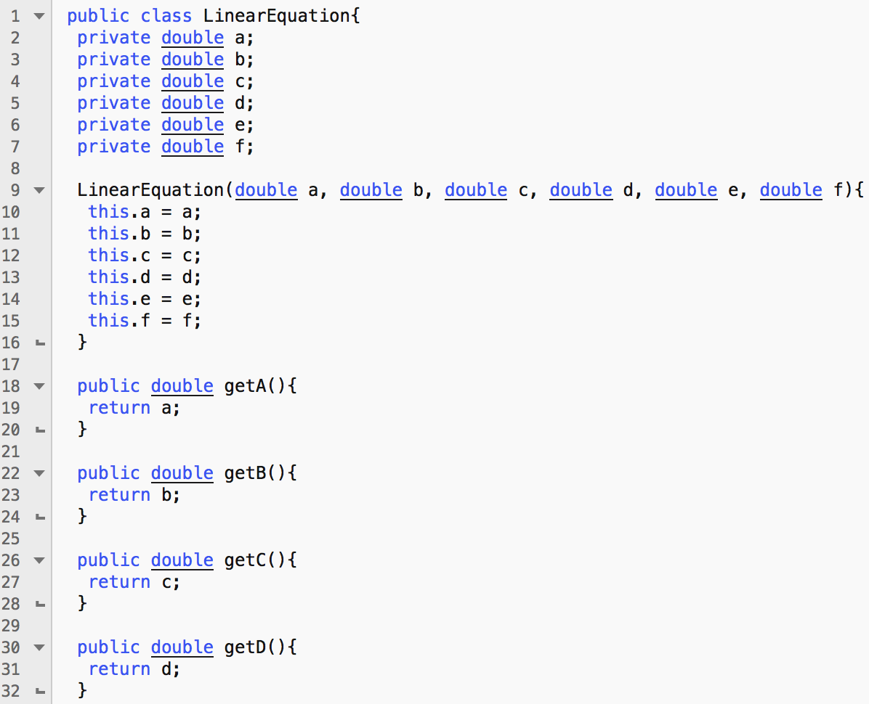

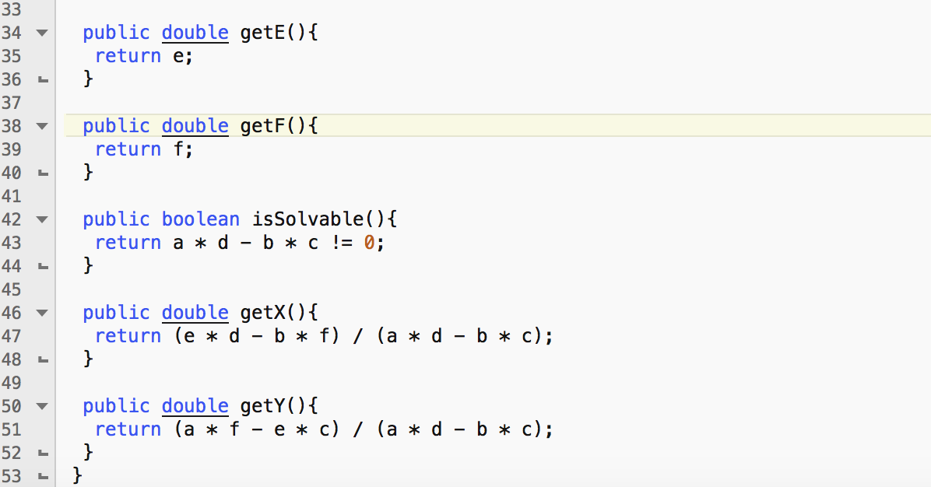

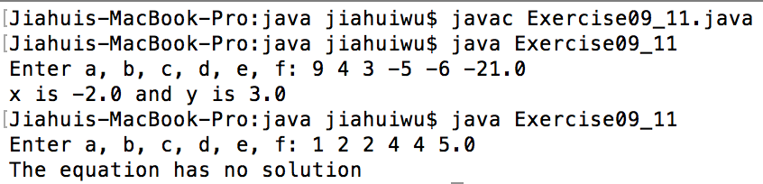

============================================================

**LinearEquation**

-----------------------------------------------------------------------------------------------------

-a: double

-b: double

-c: double

-d: double

-e: double

-f: double

-----------------------------------------------------------------------------------------------------

+LinearEquation(a: double, b: double, c: double, d: double, e: double, f: double)

+getA(): double

+getB(): double

+getC(): double

+getD(): double

+getE(): double

+getF(): double

+isSolvable(): boolean

+getX(): double

+getY(): double

Exercise09_12

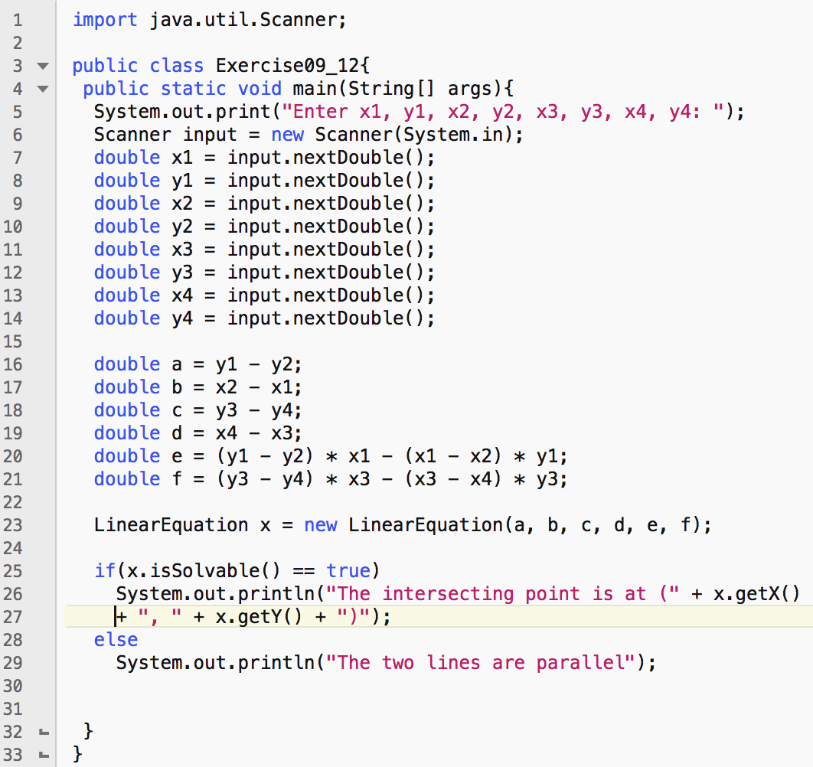

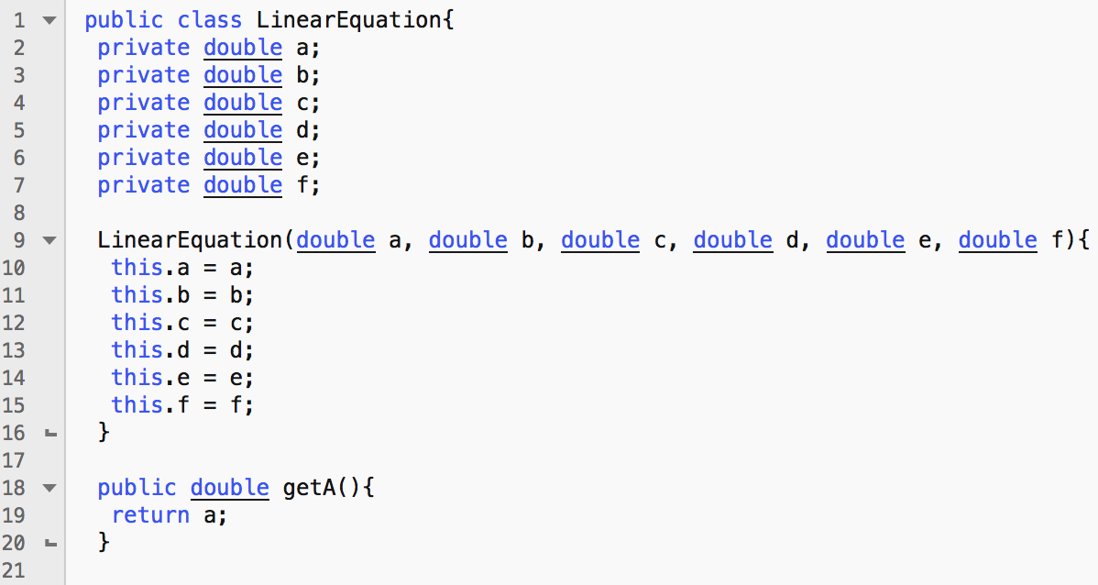

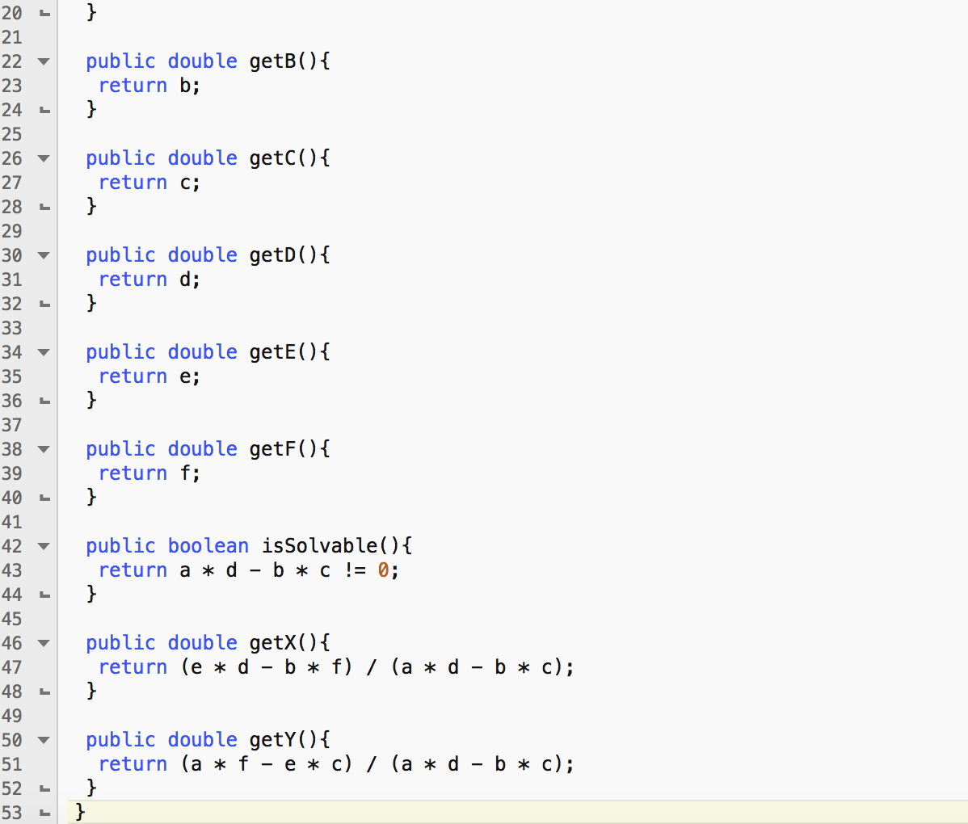

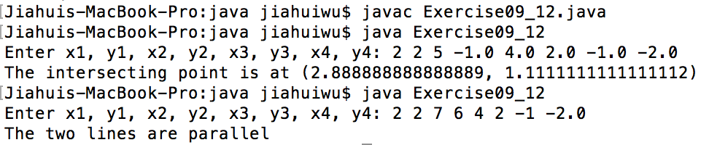

Exercise09_13

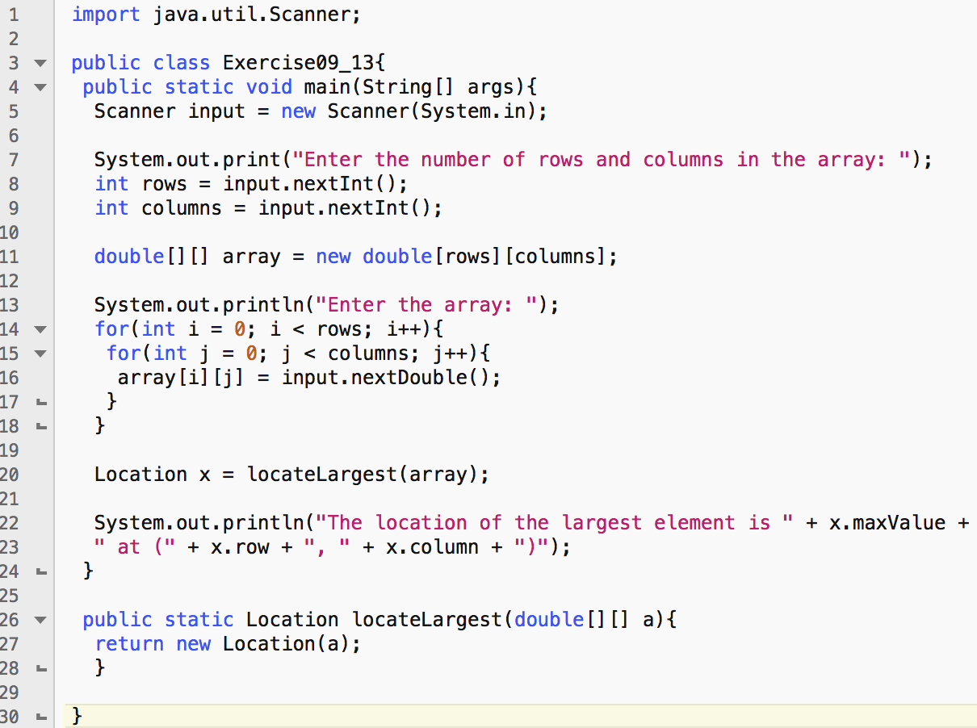

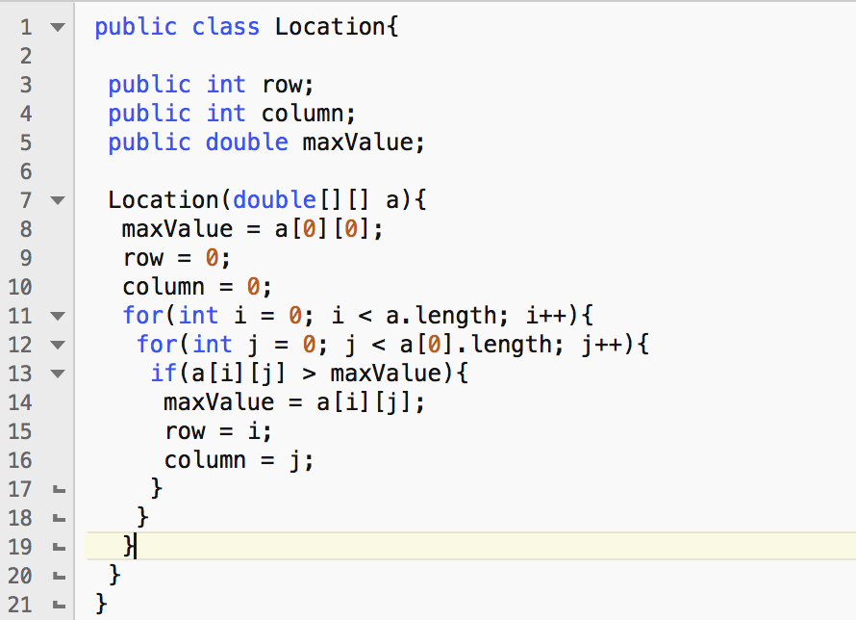

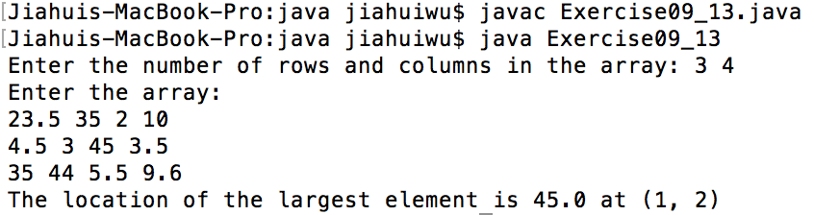

Exercise10_13

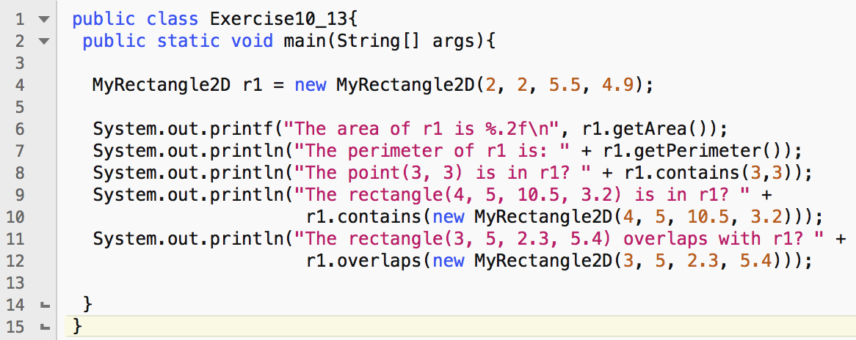

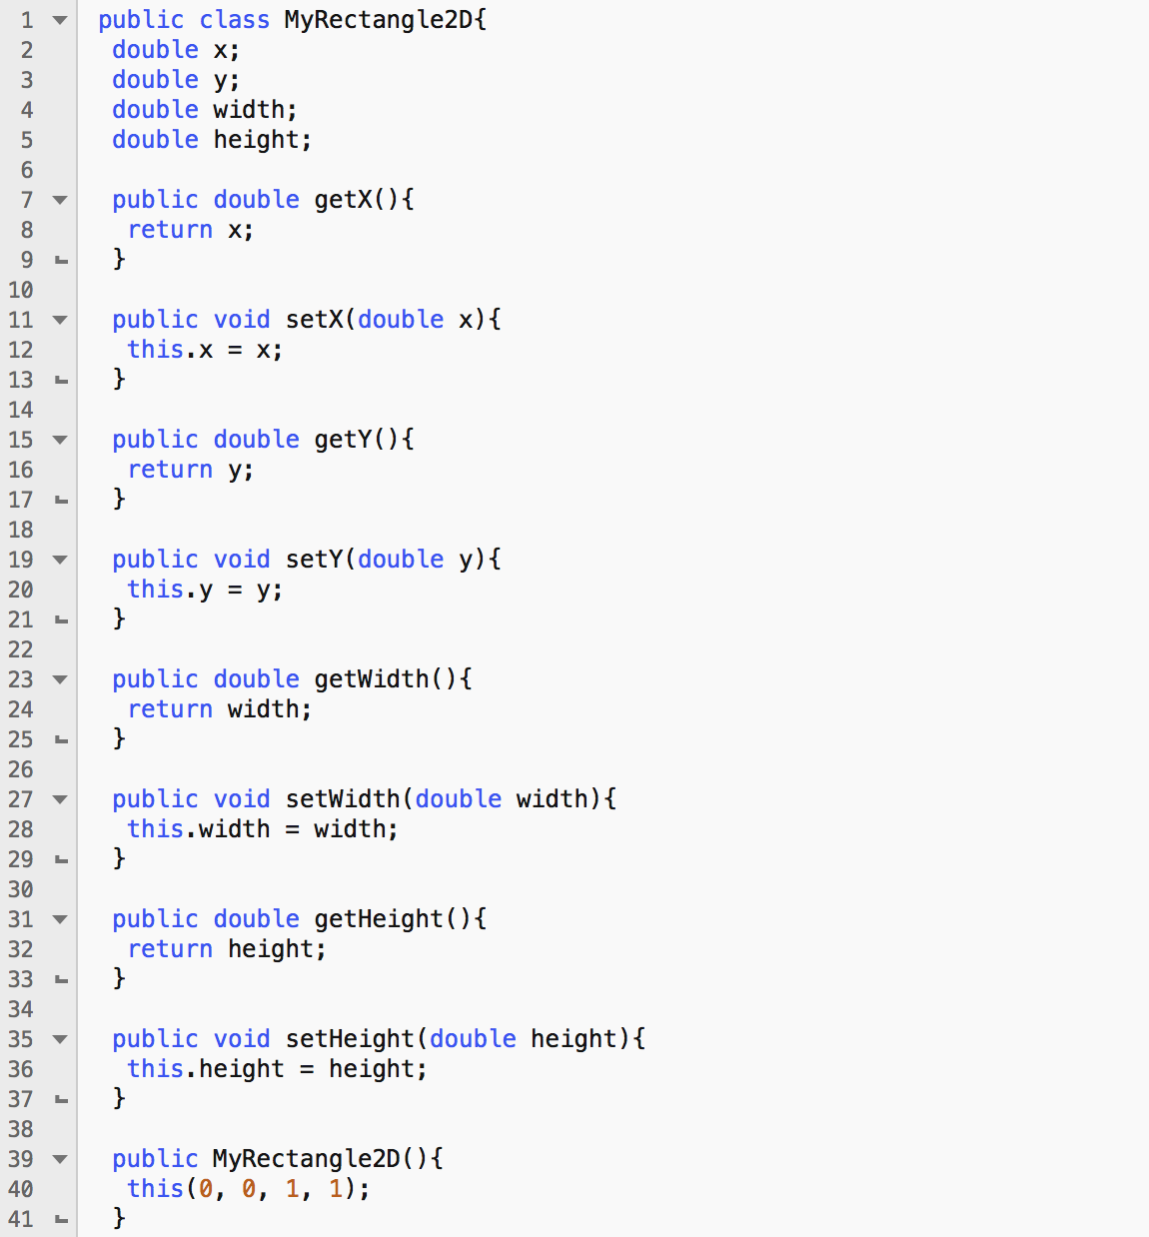

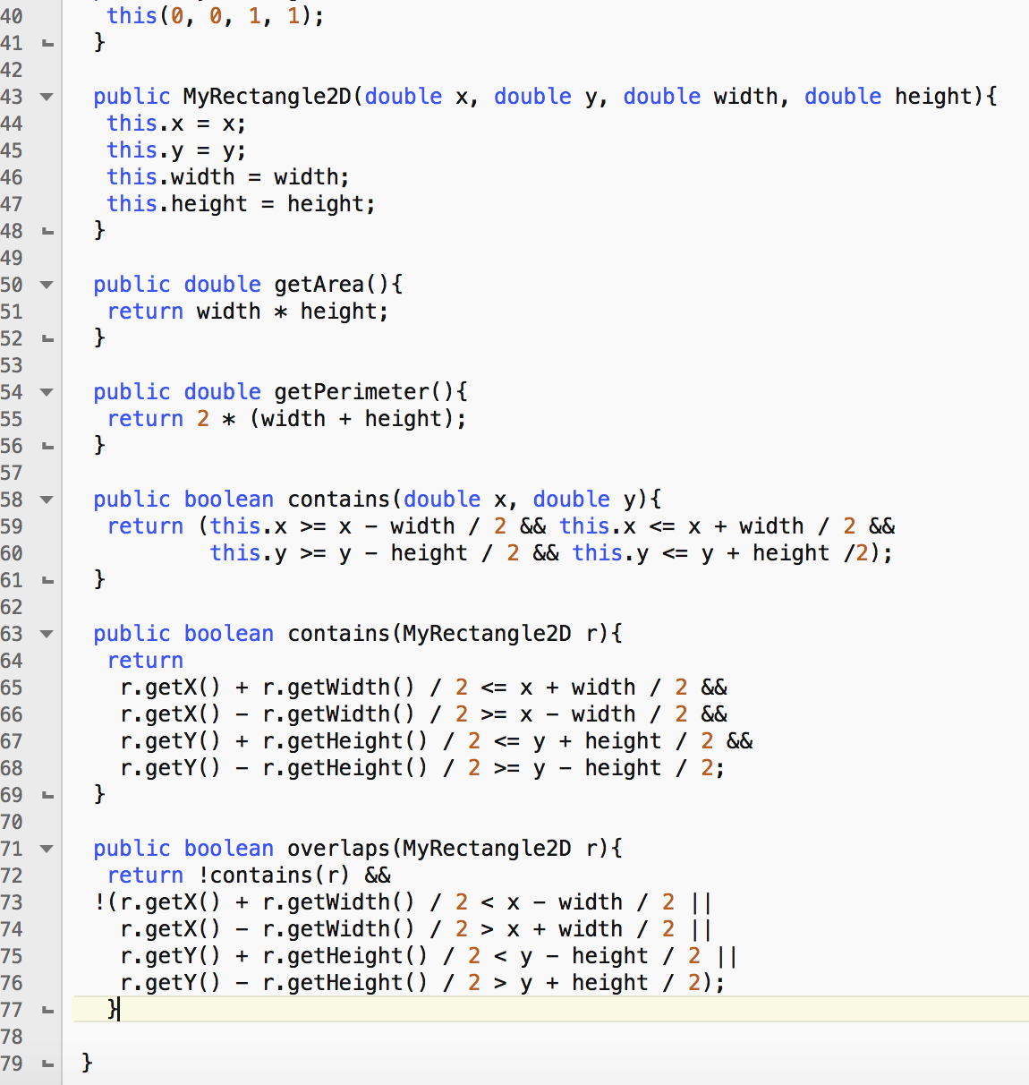

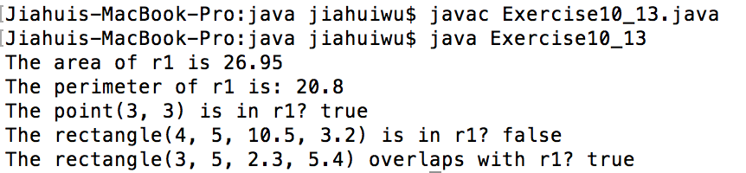

=====================================================

**MyRectangle2D**

----------------------------------------------------------------------------------------

x: double

y: double

width: double

height: double

----------------------------------------------------------------------------------------

+MyRectangle2D()

+MyRectangle2D(x: double, y: double, width: double, height: double)

+getx(): double

+gety(): double

+getWidth(): double

+getHeight(): double

+setX(x: double)

+setY(y: double)

+setWidth(width: double)

+setHeight(height: double)

+getArea(): double

+getPerimeter(): double

+contains(x: double, y: double)

+contains(r: MyRectangle2D)

+overlaps(r: MyRectangle2D)

=====================================================

Exercise10_22